EXERCISE 2
1. Write the SELECT statement to extract the ids of employees who are more than 30 years of age.
SELECT emp_id FROM employee_data WHERE age > 30;
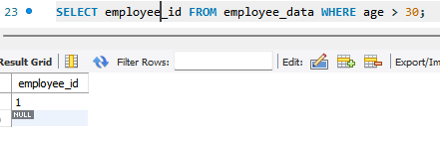

2. Write the SELECT statement to extract the first and last name of all web designers.
SELECT f_name, l_name FROM employee_data WHERE title = 'Web Designer';
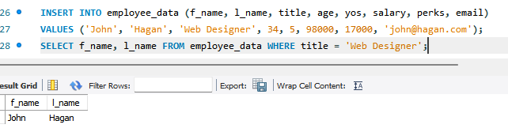

3. What will the following SELECT statement display:
SELECT * FROM employee_data WHERE salary <= 100000;
This will display all columns for employees whose salary is less than or equal to 100,000.

4. How will you display the salaries and perks for employees who have more than 16,000 as perks?
SELECT salary, perks FROM employee_data WHERE perks > 16000;

5. List all employee names (last name followed by first name) who hold the title of Marketing Executive.
SELECT l_name, f_name FROM employee_data WHERE title = 'Marketing Executive';

